ONLINE SHOPPING SYSTEM
A DBMS Capstone Project Report submitted in partial fulfillment of the requirements for the award of the degree of
BACHELOR OF TECHNOLOGY
in
ARTIFICIAL INTELLIGENCE AND MACHINE LEARNING
Submitted By
CHINTA SAHITHI – 25B11AI210
GOLLAVILLI RESHMA APARNA – 25B11AI352
NARLA BALA CHANDRA VEERA MANIKANTA ESWAR – 25B11AI827
ELLIPE SUSHANTH ABHINAY DAS – 25B11AI297

Under the esteemed guidance of
Mr. T.Srinivasulu M.Tech, (Ph.D.)
Assistant Professor


DEPARTMENT OF ARTIFICIAL INTELLIGENCE AND MACHINE LEARNING
ADITYA UNIVERSITY
(Formerly Aditya Engineering College (A))
Aditya Nagar, ADB Road, Surampalem, Andhra Pradesh, India
2026 – 2027

Aditya Nagar, ADB Road, Surampalem, Andhra Pradesh, India
DEPARTMENT OF ARTIFICIAL INTELLIGENCE AND MACHINE LEARNING
CERTIFICATE
This is to certify that the DBMS Capstone Project report entitled” ONLINE SHOPPING SYSTEM” is being submitted by CHINTA SAHITHI (Roll No.25B11AI210), GOLLAVILLI RESHMA APARNA (Roll No.25B11AI352), NARLA BALA CHANDRA VEERA MANIKANTA ESWAR (Roll No. 25B11AI827) and ELLIPE SUSHANTH ABHINAY DAS (Roll No. 25B11AI297) in partial fulfillment of the requirements for the award of the B.Tech degree in Artificial Intelligence and Machine Learning. The work documented in this report was carried out as part of the Capstone Project for the course Database Management Systems (2501IT05) during the academic year 2026–2027, and records the database design, implementation, and documentation undertaken by the team.

Project Guide Head of the Department
Mr. T. Srinivasulu, M. Tech, (Ph.D.) Dr. K. Naga Bhargavi, M. Tech, Ph.D. Associate professor Associate Professor & HOD

External Examiner

DECLARATION
We declare that the report entitled “ONLINE SHOPPING SYSTEM” has been prepared for academic purposes
DECLARATION
We hereby declare that the DBMS Capstone Project entitled “ONLINE SHOPPING SYSTEM” is a genuine work carried out by us. The database design, SQL implementation, queries and documentation presented in this report are our own work, completed under the guidance of T. Srinivasulu, Department of Artificial intelligence and machine learning, Aditya University, Surampalem. We further declare that this work has not been submitted, in full or in part, for the award of any degree of this or any other educational institution.

Project Associates
CHINTA SAHITHI (25B11AI210)
GOLLAVILLI RESHMA APARNA (25B11AI352)
NARLA BALA CHANDRA VEERA MANIKANTA ESWAR(25B11AI827)
ELLIPE SUSHANTH ABHINAY DAS(25B11AI297)

Date:
Place: Surampalem

ACKNOWLEDGEMENT
It is with immense pleasure that we express our indebted gratitude to our project guide T. Srinivasulu, Department of ARTIFICIAL INTELLIGENCE AND MACHINE LEARNING, who guided us throughout the capstone project. We are thankful for the constant encouragement and valuable suggestions received at every review stage.
We are grateful to K. Naga Bhargavi, Head of the Department, for inspiring us and for arranging the facilities and resources needed for this project.
We extend our sincere thanks to the Management, Dr. M. Sreenivasa Reddy, Deputy Pro-Chancellor, Dr. M. B. Srinivas, Vice-Chancellor, and Dr. A. Ramesh, Pro Vice-Chancellor (Engineering & Sciences), for providing an excellent academic environment.
Not to forget, we thank the Teaching and Non-Teaching Staff, our parents and our friends, who have directly or indirectly supported us in completing this project on time.

Project Associates
CHINTA SAHITHI (25B11AI210)
GOLLAVILLI RESHMA APARNA (25B11AI352)
NARLA BALA CHANDRA VEERA MANIKANTA ESWAR(25B11AI827)
ELLIPE SUSHANTH ABHINAY DAS( 25B11AI297)

ABSTRACT
Online shopping platforms coordinate users, sellers, products, categories, carts, orders, reviews and return requests. These records are interdependent: sellers list products, users add products to carts, orders represent purchases, reviews provide product feedback, and return requests refer back to completed orders. The Online Shopping System project models this domain as a relational database with eight primary entities and corresponding tables: Users, Seller, Category, Product, Cart, Orders, Review and Return_Request. The supplied design uses MySQL-style DDL with primary keys, foreign keys, unique constraints, NOT NULL rules, CHECK constraints and default values. It also identifies derived values such as final price, cart total, order total, seller rating and total sales, and multi-valued concepts such as phone numbers and product images. The report covers the domain study, entity and relationship design, relational schema, normalization from UNF to 3NF, DDL, sample data, validation rules, SQL queries, views, set operations, DCL and TCL examples, testing and future enhancements. The documented outcome is a consistent foundation for managing online-shopping information, while the source-level omissions of supporting Address, Order_Item, User_Phone and Product_Images tables are recorded explicitly for future completion

INDEX
Chapter | Title | Page No.
 | Certificate | i
 | Declaration | ii
 | Acknowledgement | iii
 | Abstract | iv
 | List of Figures | v
 | List of Tables | vi
1 | Introduction | 9
 | 1.1 Introduction to the Domain | 9
 | 1.2 Problem Statement | 9
 | 1.3 Motivation and Need for a Database | 9
 | 1.4 Objectives of the Project | 9
 | 1.5 Scope of the Project | 10
 | 1.6 Organization of the Report | 10
2 | System Study and Tools | 11
 | 2.1 Existing System and Its Limitations | 11
 | 2.2 Proposed Database System | 11
 | 2.3 Tools and Technologies Used | 11
 | 2.4 Software and Hardware Requirements | 12
3 | Database Design (Review – I) | 13
 | 3.1 Identified Entities | 13
 | 3.2 Entity Attributes and Attribute Types | 13
 | 3.3 ER Diagram | 15
 | 3.4 Relationships and Cardinality | 16
 | 3.5 Relational Database Schema | 16
 | 3.6 Primary Keys and Foreign Keys | 18
 | 3.7 Normalization up to 3NF | 18
4 | Database Implementation (Review – II) | 20
 | 4.1 Database and Table Creation – DDL | 20
 | 4.2 Sample Data Insertion – DML | 22
 | 4.3 Constraints and Data Integrity | 24
 | 4.4 Data Validation Rules | 25
5 | SQL Operations and Queries | 26
 | 5.1 DQL – Basic Retrieval Queries | 26
 | 5.2 Join Operations | 26
 | 5.3 Aggregate Functions, GROUP BY and HAVING | 27
 | 5.4 Nested and Correlated Subqueries | 27
 | 5.5 Views and Relational Set Operations | 27
 | 5.6 DCL and TCL Operations | 27
6 | Modules and Functionalities | 38
7 | Results – Sample Outputs and Screenshots | 40
8 | Testing and Data Validation | 42
9 | GitHub Repository and Team Contribution | 42
10 | Conclusion and Future Enhancements | 43
 | References | 44
 | Appendix A – Complete SQL Script | 44

LIST OF FIGURES
Figure No. | Title of the Figure | Page No.
Fig. 3.1 | ER Diagram of the Online Shopping System | 12
Fig. 3.2 | Relational Schema Diagram | 13
Fig. 4.1 | Successful Creation of Tables | 20
Fig. 4.2 | Sample Data Inserted into the Tables | 22
Fig. 4.3 | Referential Integrity Enforced by the Database | 24
Fig. 7.1 | User and Product Retrieval Output | 40
Fig. 7.2 | Product Review Summary Output | 40
Fig. 7.3 | Aggregate Product Analysis Output | 41
Fig. 7.4 | Constraint Validation Output | 41

LIST OF TABLES
Table No. | Title of the Table | Page No.
Table 2.1 | Tools and Technologies Used | 11
Table 2.2 | Software and Hardware Requirements | 11
Table 3.1 | Entities Identified for the Selected Domain | 12
Table 3.2 | Attributes of Each Entity | 13
Table 3.3 | Relationships and Cardinality | 15
Table 3.4 | Relational Database Schema | 16
Table 3.5 | Primary Key and Foreign Key Definitions | 16
Table 3.6 | Normalization Steps | 18
Table 4.1 | Sample Data Summary | 20
Table 4.2 | Constraints and Data Integrity Rules | 22
Table 5.1 | Basic Retrieval Queries | 26
Table 5.2 | Join Operations | 28
Table 5.3 | Aggregate, GROUP BY and HAVING Queries | 30
Table 5.4 | Subqueries | 32
Table 5.5 | Views and Set Operations | 33
Table 5.6 | DCL and TCL Operations | 36
Table 6.1 | Modules and Their Functionalities | 38
Table 8.1 | Test Cases and Results | 42
Table 9.1 | Team Responsibilities | 42
Table 9.2 | Review-wise Progress Record | 43

CHAPTER 1: INTRODUCTION

Introduction to the Domain
Online shopping is an e-commerce activity in which users discover products, evaluate prices and reviews, place orders and request returns through a digital platform. A shopping database must connect identity and access information with seller profiles, product listings, categories, cart entries, order records, reviews and return requests. Each record has business meaning only in relation to other records: a product belongs to a seller and category, a cart entry belongs to a user and product, and a return request refers to an order and its requesting user.
The supplied Online Shopping System design focuses on eight primary entities: User, Seller, Product, Cart, Order, Review, Return_Request and Category. It identifies additional multi-valued or associative concepts—user phone numbers, product images, addresses and order items—but the supplied DDL creates only the eight primary tables. This report distinguishes the documented logical design from the exact executable DDL so that omitted supporting tables are not represented as implemented features.

Problem Statement
Without a centralized database, online-shopping information can be duplicated across user records, product catalogues, cart files, order records and feedback sheets. Such duplication can make it difficult to maintain a single current value for an email address, seller identity, product price or order state. It can also make it difficult to determine which user owns a cart entry, which seller listed a product, or which order is associated with a return request.
The proposed relational design addresses these risks through primary keys, foreign keys, uniqueness rules, non-null requirements, range checks and default values. The source design also separates derived business values such as final price and order total from base data. The exact referential behavior of the supplied DDL is documented in Chapter 4.

1.3 Motivation and Need for a Database
A DBMS is required because online-shopping records are shared by many logical processes and are updated over time. Relational constraints prevent duplicate identifiers and invalid references, while transactions can protect a group of related updates. SQL also makes it possible to retrieve products, summarize reviews, compare prices and report order activity without maintaining separate manually calculated lists. Normalization reduces repeated facts, while historical values such as order-line prices should be kept in an order-item structure when that structure is implemented.

1.4 Objectives of the Project
- To design a normalized relational database for an Online Shopping System using the eight primary entities defined in the reference document.
- To represent users, sellers, categories, products, carts, orders, reviews and return requests with suitable keys and relationships.
- To implement MySQL-style DDL using primary keys, foreign keys, UNIQUE, NOT NULL, CHECK and DEFAULT constraints.
- To demonstrate at least fifteen SQL operations covering retrieval, joins, aggregation, subqueries, views, set operations, DCL and TCL.
- To document data validation, normalization, sample records, implementation limitations and future enhancements without claiming missing tables or execution evidence.

1.5 Scope of the Project
The documented scope includes the eight primary tables and the attributes described in the supplied reference: account and role information in Users; seller identity; product and category data; cart entries; order status; product reviews; and return requests. It also includes the database design concepts needed to discuss addresses, order items, user phone numbers and product images because the reference mentions them.
The supplied executable DDL does not create Address, Order_Item, User_Phone or Product_Images. Therefore, address persistence, multi-line order storage, multiple phone storage and multiple image storage are treated as design gaps rather than implemented modules. Payment processing, live inventory synchronization, shipping-provider integration, password authentication logic and a graphical front end are also outside the demonstrated DDL.

1.6 Organization of the Report
This report is organized into ten chapters. Chapter 2 presents the system study and tools used. Chapter 3 covers the database design, attributes, relationships, schema and normalization. Chapter 4 describes DDL, sample data and constraints. Chapter 5 presents SQL operations, views, set operations, DCL and TCL examples. Chapter 6 explains the functional modules. Chapter 7 identifies the result evidence available from the source. Chapter 8 records validation cases. Chapter 9 documents repository and team information. Chapter 10 concludes the work and states limitations and future enhancements.

CHAPTER 2: SYSTEM STUDY AND TOOLS

2.1 Existing System and Its Limitations
The reference document does not describe a deployed legacy system. For this capstone, the motivating comparison is a fragmented arrangement in which user, seller, product, shopping-cart, order and review information is maintained separately or without enforced relational links. The limitations of such an arrangement are data duplication, inconsistent updates, weak validation, difficult reporting and a higher risk of orphan records.
- A user, seller or product may be represented more than once.
- Product, category and seller relationships may not be validated consistently.
- A cart or review may refer to a missing user or product if foreign keys are absent.
- Order totals, seller ratings and product prices may be calculated manually and become inconsistent.
- Cross-module reports require manual compilation when data is not centralized.

2.2 Proposed Database System
The proposed system is a relational database with eight primary tables. Users stores login and role information. Seller extends a user into a store profile. Category classifies products, Product stores seller listings, Cart stores a user’s selected product and quantity, Orders stores purchase status, Review stores product feedback, and Return_Request stores return information linked to an order.
The reference DDL applies AUTO_INCREMENT primary keys, UNIQUE constraints on identity fields, foreign keys across core relationships, CHECK constraints for price, quantity and rating, and DEFAULT values for role, timestamps and statuses. The design is intended to support SQL reports and controlled updates, while its missing supporting tables are recorded for future implementation.

2.3 Tools and Technologies Used
Category | Tool / Technology Used | Version / Remarks
Database Server | MySQL-compatible SQL | 8.0 — relational DBMS used for implementation
Query / Admin Tool | MySQL Workbench | 8.0 CE — script execution and output capture
ER Diagram Tool | draw.io (diagrams.net) | Web version — ER and schema diagrams
Version Control | Git and GitHub | Team repository for the SQL script
Documentation | Microsoft Word-compatible DOCX | 365 — report preparation
Programming / Front End | dbfiddle.dev | Used to verify queries independently

2.4 Software and Hardware Requirements
Requirement Type | Specification
Operating System | Windows 10 / 11 (64-bit) or Ubuntu 22.04
Database Server | MySQL 8.0 or above
Client Tool | MySQL Workbench 8.0 CE / MySQL command-line client
Processor | Intel Core i3 or above
RAM | 4 GB minimum, 8 GB recommended
Disk Space | 2 GB free (server, sample data and documentation)

CHAPTER 3: DATABASE DESIGN

3.1 Identified Entities
S.No | Entity Name | Description
1 | User / Users | Stores usernames, email addresses, password hashes, roles and account creation timestamps.
2 | Seller | Represents a seller profile linked one-to-one with a user account.
3 | Product | Stores products listed by sellers, including price, discount, stock and category reference.
4 | Cart | Stores products selected by a user and their quantities.
5 | Order / Orders | Stores the user who placed an order, order time, status and estimated delivery.
6 | Review | Stores a user’s rating and comment for a product.
7 | Return_Request | Stores a return request, its reason, status and refund amount.
8 | Category | Stores product category names.

3.2 Entity Attributes and Attribute Types
Entity | Attribute | Data Type | Key / Constraint | Attribute Type
User | user_id | INT | PK | Simple
User | username | VARCHAR(50) | UNIQUE, NOT NULL | Simple
User | email | VARCHAR(100) | UNIQUE, NOT NULL | Simple
User | password_hash | VARCHAR(255) | NOT NULL | Simple
User | user_role | VARCHAR(20) | DEFAULT Buyer | Simple
User | created_at | DATETIME | DEFAULT CURRENT_TIMESTAMP | Simple
User | full_name | VARCHAR(100) | — | Composite
User | phone_numbers | TEXT | Multi-valued; User_Phone named in reference | Multi-valued
Seller | seller_id | INT | PK | Simple
Seller | user_id | INT | FK → Users; UNIQUE NOT NULL | Simple
Seller | shop_name | VARCHAR(100) | UNIQUE NOT NULL | Simple
Seller | gst_number | VARCHAR(20) | UNIQUE | Simple
Seller | rating | DECIMAL(3,2) | Derived | Derived
Seller | total_sales | INT | Derived | Derived
Seller | bank_account | VARCHAR(20) | — | Simple
Product | product_id | INT | PK | Simple
Product | seller_id | INT | FK → Seller; NOT NULL | Simple
Product | product_name | VARCHAR(200) | NOT NULL | Simple
Product | category_id | INT | FK → Category | Simple
Product | price | DECIMAL(10,2) | NOT NULL; CHECK price ≥ 0 | Simple
Product | discount_pct | DECIMAL(5,2) | DEFAULT 0 | Simple
Product | final_price | DECIMAL(10,2) | Derived | Derived
Product | stock | INT | DEFAULT 0 | Simple
Product | images | TEXT | Multi-valued; Product_Images named in reference | Multi-valued
Cart | cart_id | INT | PK | Simple
Cart | user_id | INT | FK → Users; NOT NULL | Simple
Cart | product_id | INT | FK → Product; NOT NULL | Simple
Cart | quantity | INT | NOT NULL; CHECK quantity > 0 | Simple
Cart | added_at | DATETIME | DEFAULT CURRENT_TIMESTAMP | Simple
Cart | cart_total | DECIMAL(10,2) | Derived | Derived
Order | order_id | INT | PK | Simple
Order | user_id | INT | FK → Users; NOT NULL | Simple
Order | order_date | DATETIME | DEFAULT CURRENT_TIMESTAMP | Simple
Order | delivery_address_id | INT | FK → Address in conceptual design; table absent from DDL | Simple
Order | total_amount | DECIMAL(10,2) | Derived | Derived
Order | order_status | VARCHAR(30) | DEFAULT Placed | Simple
Order | estimated_delivery | DATE | — | Simple
Review | review_id | INT | PK | Simple
Review | product_id | INT | FK → Product; NOT NULL | Simple
Review | user_id | INT | FK → Users; NOT NULL | Simple
Review | rating | INT | CHECK 1–5 | Simple
Review | comment | TEXT | — | Simple
Review | review_date | DATE | DEFAULT CURRENT_DATE | Simple
Review | helpful_votes | INT | DEFAULT 0 | Simple
Return_Request | return_id | INT | PK | Simple
Return_Request | order_id | INT | FK → Orders; UNIQUE NOT NULL | Simple
Return_Request | user_id | INT | FK → Users; NOT NULL | Simple
Return_Request | reason | TEXT | — | Simple
Return_Request | return_date | DATE | — | Simple
Return_Request | status | VARCHAR(20) | DEFAULT Requested | Simple
Return_Request | refund_amount | DECIMAL(10,2) | — | Simple
Category | category_id | INT | PK | Simple
Category | category_name | VARCHAR(100) | UNIQUE NOT NULL | Simple

3.3 ER Diagram

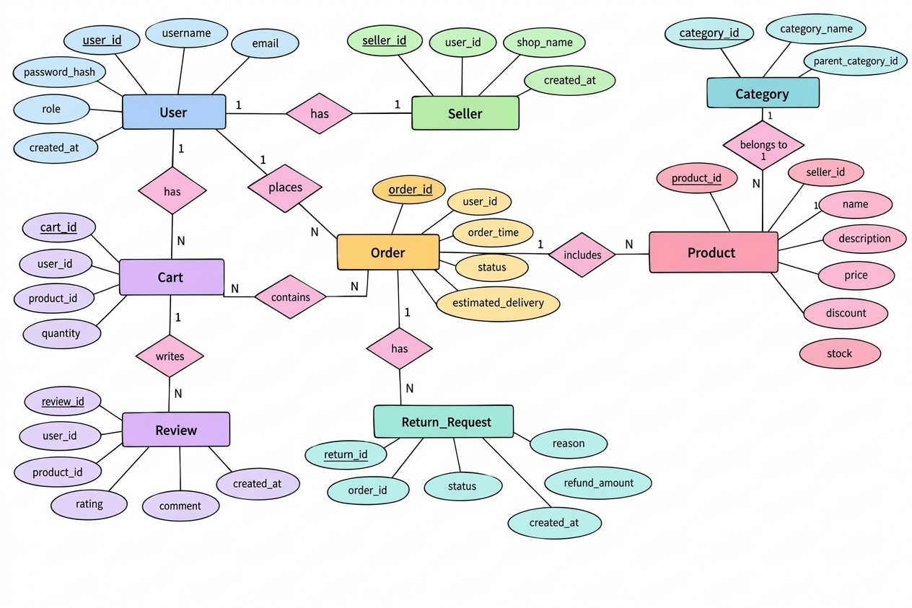
Fig. 3.1: ER Diagram of the Online shopping System

3.4 Relationships and Cardinality
Entity 1 | Relationship | Entity 2 | Cardinality | Participation
Users | has profile | Seller | 1:1 | Seller participation total; User partial
Seller | lists | Product | 1:N | Product total if seller_id NOT NULL
Category | classifies | Product | 1:N | Product partial because category_id is nullable
Users | contains | Cart | 1:N | Cart total
Users | places | Orders | 1:N | Order total
Orders | contains | Product via Order_Item | M:N | Conceptual; Order_Item absent from DDL
Users | writes | Product through Review | M:N | Review resolves association
Orders | has | Return_Request | 1:1 | Return_Request total; order_id UNIQUE
Orders | uses | Address | N:1 | Conceptual; Address table absent from DDL

3.5 Relational Database Schema
Table Name | Column Name | Key | Constraints
Users | user_id INT | PK | AUTO_INCREMENT
Users | username VARCHAR(50) | — | UNIQUE, NOT NULL
Users | email VARCHAR(100) | — | UNIQUE, NOT NULL
Users | password_hash VARCHAR(255) | — | NOT NULL
Users | user_role VARCHAR(20) | — | DEFAULT Buyer
Users | created_at DATETIME | — | DEFAULT CURRENT_TIMESTAMP
Seller | seller_id INT | PK | AUTO_INCREMENT
Seller | user_id INT | FK | UNIQUE, NOT NULL; REFERENCES Users
Seller | shop_name VARCHAR(100) | — | UNIQUE, NOT NULL
Seller | gst_number VARCHAR(20) | — | UNIQUE
Seller | bank_account VARCHAR(20) | — | —
Category | category_id INT | PK | AUTO_INCREMENT
Category | category_name VARCHAR(100) | — | UNIQUE, NOT NULL
Product | product_id INT | PK | AUTO_INCREMENT
Product | seller_id INT | FK | NOT NULL; REFERENCES Seller
Product | product_name VARCHAR(200) | — | NOT NULL
Product | category_id INT | FK | REFERENCES Category
Product | price DECIMAL(10,2) | — | NOT NULL, CHECK price >= 0
Product | discount_pct DECIMAL(5,2) | — | DEFAULT 0
Product | stock INT | — | DEFAULT 0
Cart | cart_id INT | PK | AUTO_INCREMENT
Cart | user_id INT | FK | NOT NULL; REFERENCES Users
Cart | product_id INT | FK | NOT NULL; REFERENCES Product
Cart | quantity INT | — | NOT NULL, CHECK quantity > 0
Cart | added_at DATETIME | — | DEFAULT CURRENT_TIMESTAMP
Orders | order_id INT | PK | AUTO_INCREMENT
Orders | user_id INT | FK | NOT NULL; REFERENCES Users
Orders | order_date DATETIME | — | DEFAULT CURRENT_TIMESTAMP
Orders | order_status VARCHAR(30) | — | DEFAULT Placed
Orders | estimated_delivery DATE | — | —
Review | review_id INT | PK | AUTO_INCREMENT
Review | product_id INT | FK | NOT NULL; REFERENCES Product
Review | user_id INT | FK | NOT NULL; REFERENCES Users
Review | rating INT | — | CHECK rating BETWEEN 1 AND 5
Review | comment TEXT | — | —
Review | review_date DATE | — | DEFAULT CURRENT_DATE
Review | helpful_votes INT | — | DEFAULT 0
Return_Request | return_id INT | PK | AUTO_INCREMENT
Return_Request | order_id INT | FK | UNIQUE, NOT NULL; REFERENCES Orders
Return_Request | user_id INT | FK | NOT NULL; REFERENCES Users
Return_Request | reason TEXT | — | —
Return_Request | return_date DATE | — | —
Return_Request | status VARCHAR(20) | — | DEFAULT Requested
Return_Request | refund_amount DECIMAL(10,2) | — | —
Schema Diagram
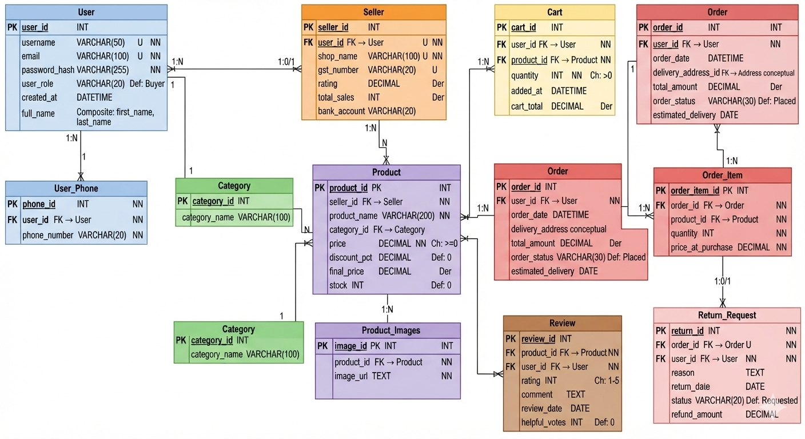
Fig. 3.2: Relational Schema Diagram

3.6 Primary Keys and Foreign Keys
Table | Primary Key | Foreign Key | References (Table.Column)
Users | user_id | — | —
Seller | seller_id | user_id | Users.user_id
Category | category_id | — | —
Product | product_id | seller_id / category_id | Seller.seller_id / Category.category_id
Cart | cart_id | user_id / product_id | Users.user_id / Product.product_id
Orders | order_id | user_id | Users.user_id
Review | review_id | product_id / user_id | Product.product_id / Users.user_id
Return_Request | return_id | order_id / user_id | Orders.order_id / Users.user_id

3.7 Normalization up to 3NF
The unnormalized design can be represented conceptually as a wide shopping relation containing user details, seller details, product details, cart values, order values, review values and return values in the same record. Such a relation would repeat user data for every cart, order and review, and product data for every cart or order line.
UNF: Shopping(user, seller, product, category, cart, order, review, return, phone_numbers, images, order_items)
First Normal Form (1NF): every field must be atomic and repeating groups must be separated. The source identifies phone_numbers and images as multi-valued and names User_Phone and Product_Images as separate tables. It also identifies Order_Item as the associative structure for an order containing multiple products. However, those supporting tables are not included in the supplied executable DDL, so their design is documented as a required extension rather than an implemented table.
Second Normal Form (2NF): non-key attributes must depend on the whole key. Cart uses a unique (user_id, product_id) combination in the supplied DDL, so quantity and added_at depend on the complete cart-item identity. An Order_Item table would similarly keep quantity and unit_price dependent on the complete order-line key. Seller, Product, Review and Return_Request are separated so that their attributes do not repeat for unrelated records.
Third Normal Form (3NF): non-key attributes must not depend transitively on another non-key attribute. Seller details depend on seller_id, product details depend on product_id, and user details depend on user_id. Derived values—seller rating, total sales, final_price, cart_total and total_amount—should be calculated from base records rather than stored redundantly. The supplied DDL does not physically include these derived columns.
Normal Form | Condition Satisfied | Anomaly Removed | Resulting Tables
1NF | Atomic attributes; multi-valued concepts separated conceptually | Repeating phone, image and order-item groups | Users, Product, Order_Item, User_Phone, Product_Images conceptually
2NF | Non-key attributes depend on complete row identity | Partial dependency in cart/order-line data | Cart, Orders, Order_Item, Product
3NF | No transitive dependency; derived values computed | Repeated seller, category, user and calculated totals | Users, Seller, Category, Product, Cart, Orders, Review, Return_Request

CHAPTER 4: DATABASE IMPLEMENTATION

4.1 Database and Table Creation – DDL
The following statements reproduce the MySQL-style DDL supplied for the Online Shopping System. The table name Users is used in the source instead of the singular conceptual entity name User. The source DDL creates eight tables and does not create Address, Order_Item, User_Phone or Product_Images.
CREATE TABLE Users (
user_id INT PRIMARY KEY AUTO_INCREMENT,
username VARCHAR(50) UNIQUE NOT NULL,
email VARCHAR(100) UNIQUE NOT NULL,
password_hash VARCHAR(255) NOT NULL,
user_role VARCHAR(20) DEFAULT "Buyer",
created_at DATETIME DEFAULT CURRENT_TIMESTAMP
);
CREATE TABLE Seller (
seller_id INT PRIMARY KEY AUTO_INCREMENT,
user_id INT UNIQUE NOT NULL,
shop_name VARCHAR(100) UNIQUE NOT NULL,
gst_number VARCHAR(20) UNIQUE,
bank_account VARCHAR(20),
FOREIGN KEY (user_id) REFERENCES Users(user_id)
);
CREATE TABLE Category (
category_id INT PRIMARY KEY AUTO_INCREMENT,
category_name VARCHAR(100) NOT NULL UNIQUE
);
CREATE TABLE Product (
product_id INT PRIMARY KEY AUTO_INCREMENT,
seller_id INT NOT NULL,
product_name VARCHAR(200) NOT NULL,
category_id INT,
price DECIMAL(10,2) NOT NULL CHECK (price >= 0),
discount_pct DECIMAL(5,2) DEFAULT 0,
stock INT DEFAULT 0,
FOREIGN KEY (seller_id) REFERENCES Seller(seller_id),
FOREIGN KEY (category_id) REFERENCES Category(category_id)
);
CREATE TABLE Cart (
cart_id INT PRIMARY KEY AUTO_INCREMENT,
user_id INT NOT NULL,
product_id INT NOT NULL,
quantity INT NOT NULL CHECK (quantity > 0),
added_at DATETIME DEFAULT CURRENT_TIMESTAMP,
UNIQUE (user_id, product_id),
FOREIGN KEY (user_id) REFERENCES Users(user_id),
FOREIGN KEY (product_id) REFERENCES Product(product_id)
);
CREATE TABLE Orders (
order_id INT PRIMARY KEY AUTO_INCREMENT,
user_id INT NOT NULL,
order_date DATETIME DEFAULT CURRENT_TIMESTAMP,
order_status VARCHAR(30) DEFAULT "Placed",
estimated_delivery DATE,
FOREIGN KEY (user_id) REFERENCES Users(user_id)
);
CREATE TABLE Review (
review_id INT PRIMARY KEY AUTO_INCREMENT,
product_id INT NOT NULL,
user_id INT NOT NULL,
rating INT CHECK (rating BETWEEN 1 AND 5),
comment TEXT,
review_date DATE DEFAULT (CURRENT_DATE),
helpful_votes INT DEFAULT 0,
UNIQUE (product_id, user_id),
FOREIGN KEY (product_id) REFERENCES Product(product_id),
FOREIGN KEY (user_id) REFERENCES Users(user_id)
);
CREATE TABLE Return_Request (
return_id INT PRIMARY KEY AUTO_INCREMENT,
order_id INT UNIQUE NOT NULL,
user_id INT NOT NULL,
reason TEXT,
return_date DATE,
status VARCHAR(20) DEFAULT "Requested",
refund_amount DECIMAL(10,2),
FOREIGN KEY (order_id) REFERENCES Orders(order_id),
FOREIGN KEY (user_id) REFERENCES Users(user_id)
);

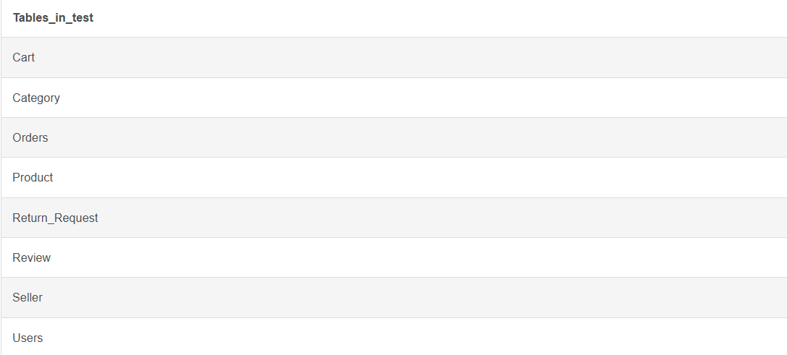

Fig. 4.1: Successful Creation of Tables

4.2 Sample Data Insertion – DML
INSERT INTO Users (user_id, username, email, password_hash, user_role, created_at) VALUES
(1, 'ravi_shop', 'ravi@shop.com', '[HASH VALUE NOT SUPPLIED]', 'Seller', '2023-01-10 09:00:00'),
(2, 'priya_buyer', 'priya@mail.com', '[HASH VALUE NOT SUPPLIED]', 'Buyer', '2023-03-15 11:30:00'),
(3, 'admin_user', 'admin@shop.com', '[HASH VALUE NOT SUPPLIED]', 'Admin', '2023-01-01 08:00:00');
INSERT INTO Seller (seller_id, user_id, shop_name)
VALUES (1, 1, 'Ravi Electronics');
INSERT INTO Category (category_id, category_name)
VALUES (1, 'Electronics');
INSERT INTO Product
(product_id, seller_id, product_name, category_id, price, discount_pct, stock)
VALUES
(1, 1, 'Wireless Headphones Sony', 1, 4999.00, 10.00, 100),
(2, 1, 'USB-C Hub 7-in-1', 1, 1299.00, 5.00, 50),
(3, 1, 'Mechanical Keyboard RGB', 1, 3499.00, 15.00, 30);
INSERT INTO Review
(review_id, product_id, user_id, rating, comment, review_date)
VALUES
(1, 1, 2, 5, 'Excellent sound quality!', '2024-07-20'),
(2, 2, 2, 4, 'Good build, slightly pricey', '2024-07-25');

S.No | Table Name | No. of Records | Screenshot Reference
1 | Users | 3 | ravi_shop, priya_buyer and admin_user
2 | Seller | 0 | No seller rows supplied
3 | Category | 0 | No category rows supplied
4 | Product | 3 | Three product rows supplied; parent seller/category rows absent
5 | Cart | 0 | No cart rows supplied
6 | Orders | 0 | No order rows supplied
7 | Review | 2 | Two review rows supplied; product/user parent rows required
8 | Return_Request | 0 | No return rows supplied

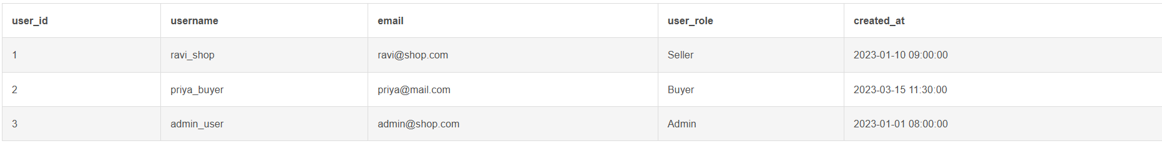
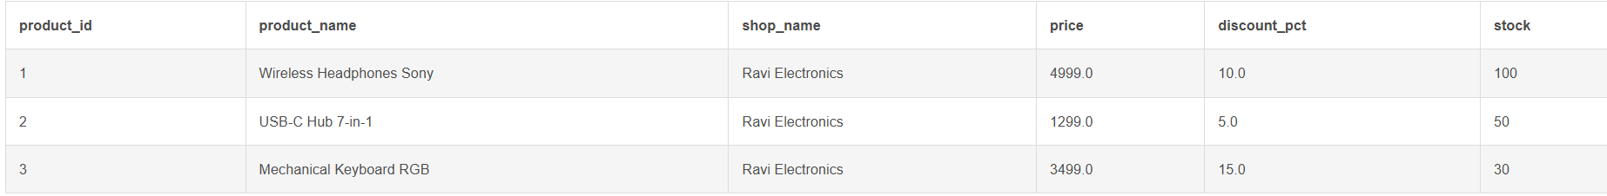
Fig. 4.2: Sample Data Inserted into the Tables

4.3 Constraints and Data Integrity
Constraint / Validation | Applied On | Purpose | Evidence / Screenshot Ref.
PRIMARY KEY | All eight tables | Uniquely identifies each row | AUTO_INCREMENT used on all supplied primary keys
UNIQUE | Users.username, Users.email | Prevents duplicate login identity values | Defined in Users DDL
UNIQUE | Seller.user_id, Seller.shop_name, Seller.gst_number | Prevents duplicate seller profile links and identifiers | Defined in Seller DDL
UNIQUE | Category.category_name | Prevents duplicate category names | Defined in Category DDL
CHECK | Product.price >= 0 | Rejects negative prices | Defined in Product DDL
CHECK | Cart.quantity > 0 | Rejects non-positive quantities | Defined in Cart DDL
UNIQUE composite | Cart(user_id, product_id) | Prevents duplicate product entries for one user | Defined in Cart DDL
CHECK | Review.rating BETWEEN 1 AND 5 | Restricts ratings to five-point scale | Defined in Review DDL
UNIQUE composite | Review(product_id, user_id) | Prevents duplicate review by a user for one product | Defined in Review DDL
UNIQUE | Return_Request.order_id | Enforces at most one return request per order | Defined in Return_Request DDL
FOREIGN KEY | Seller, Product, Cart, Orders, Review, Return_Request | Prevents references to missing parent rows | Defined in supplied DDL
DEFAULT | role, timestamps, stock, status, votes | Supplies standard values when omitted | Defined in supplied DDL

4.4 Data Validation Rules
Validation Case | Example Input | Expected Result
Duplicate user email | Insert another Users row with email ravi@shop.com | UNIQUE constraint violation
Negative product price | INSERT Product with price = -1 | CHECK constraint violation
Zero cart quantity | INSERT Cart with quantity = 0 | CHECK constraint violation
Invalid review rating | INSERT Review with rating = 6 | CHECK constraint violation
Orphan product seller | INSERT Product with seller_id not present in Seller | FOREIGN KEY violation
Duplicate cart product | Insert same user_id and product_id twice | Composite UNIQUE violation
Duplicate review | Insert same product_id and user_id twice | Composite UNIQUE violation
Second return for one order | Insert same order_id twice | UNIQUE constraint violation
Fig. 4.3: Referential Integrity Enforced by the Database

CHAPTER 5: SQL OPERATIONS AND QUERIES

5.1 DQL – Basic Retrieval Queries
Q.No | Purpose | SQL Statement | Output / Evidence
Q1 | List all users | SELECT user_id, username, email, user_role, created_at  FROM Users  ORDER BY user_id; | With supplied rows: ravi_shop, priya_buyer and admin_user.
Q2 | List products priced above 1,000 | SELECT product_id, product_name, price, stock  FROM Product  WHERE price > 1000  ORDER BY price DESC; | The three supplied product rows satisfy this filter.
Q3 | List high-rated reviews | SELECT review_id, product_id, user_id, rating, comment  FROM Review  WHERE rating >= 4  ORDER BY rating DESC; | The two supplied review rows satisfy this filter.
Q4 | List products currently in stock | SELECT product_id, product_name, stock  FROM Product  WHERE stock > 0  ORDER BY product_name; | The three supplied product rows have positive stock.
Q5 | List users by role | SELECT user_role, COUNT(*) AS user_count  FROM Users  GROUP BY user_role  ORDER BY user_role; | Expected groups are Seller, Buyer and Admin for the supplied rows.

Q1. List all users
SELECT user_id, username, email, user_role, created_at
FROM Users
ORDER BY user_id;
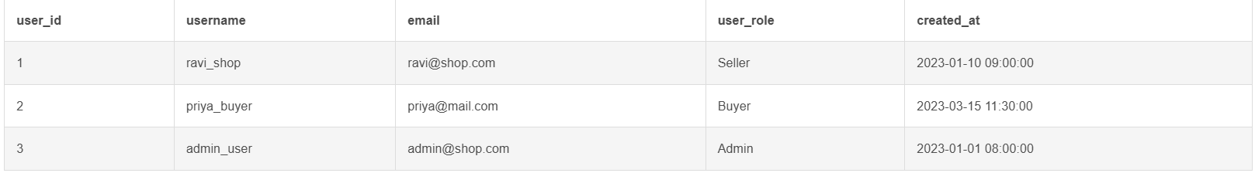

Q2. List products priced above 1,000
SELECT product_id, product_name, price, stock
FROM Product
WHERE price > 1000
ORDER BY price DESC;
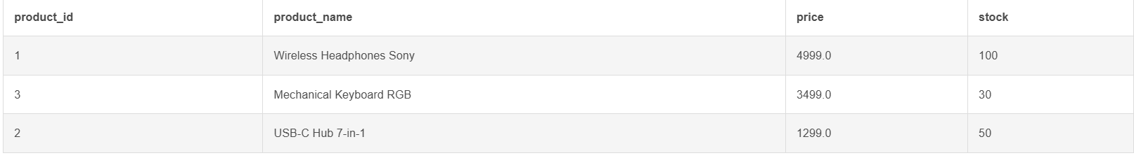

Q3. List high-rated reviews
SELECT review_id, product_id, user_id, rating, comment
FROM Review
WHERE rating >= 4
ORDER BY rating DESC;
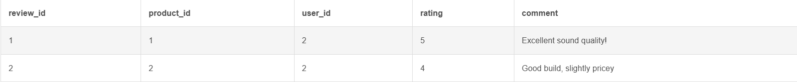

Q4. List products currently in stock
SELECT product_id, product_name, stock
FROM Product
WHERE stock > 0
ORDER BY product_name;
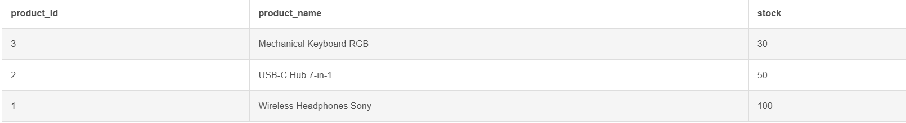

Q5. List users by role
SELECT user_role, COUNT(*) AS user_count
FROM Users
GROUP BY user_role
ORDER BY user_role;
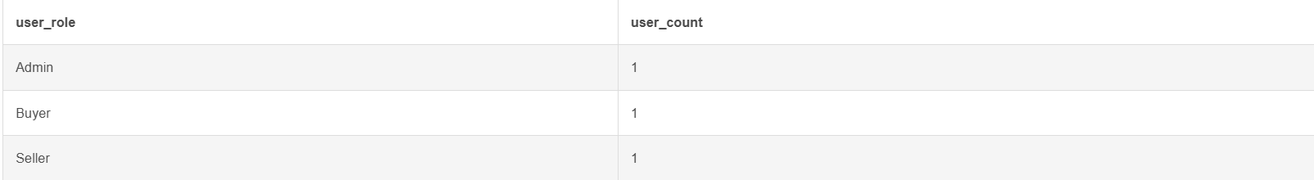

5.2 Join Operations
Q.No | Type of Join | SQL Statement | Output / Evidence
Q6 | INNER JOIN: products with seller profiles | SELECT p.product_name, s.shop_name, s.gst_number  FROM Product p  INNER JOIN Seller s ON p.seller_id = s.seller_id  ORDER BY p.product_name; | Requires Seller parent rows, which are not supplied.
Q7 | LEFT JOIN: categories and products | SELECT c.category_name, p.product_name, p.price  FROM Category c  LEFT JOIN Product p ON c.category_id = p.category_id  ORDER BY c.category_name, p.product_name; | Requires Category rows, which are not supplied.
Q8 | Three-table join: review, user and product | SELECT u.username, p.product_name, r.rating, r.comment  FROM Review r  JOIN Users u ON r.user_id = u.user_id  JOIN Product p ON r.product_id = p.product_id  ORDER BY r.rating DESC; | Uses the supplied Users, Product and Review rows.
Q9 | Cart entries with user and product details | SELECT u.username, p.product_name, c.quantity, c.added_at  FROM Cart c  JOIN Users u ON c.user_id = u.user_id  JOIN Product p ON c.product_id = p.product_id  ORDER BY c.added_at; | No Cart rows are supplied.
Q10 | Orders with return status | SELECT o.order_id, o.order_status, rr.status AS return_status  FROM Orders o  LEFT JOIN Return_Request rr ON o.order_id = rr.order_id  ORDER BY o.order_id; | No Orders or Return_Request rows are supplied.

Q6. INNER JOIN: products with seller profiles
SELECT p.product_name, s.shop_name, s.gst_number
FROM Product p
INNER JOIN Seller s ON p.seller_id = s.seller_id
ORDER BY p.product_name;
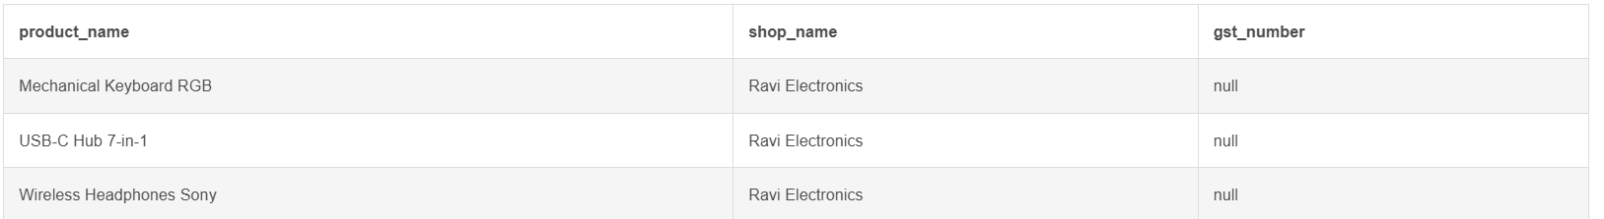

Q7. LEFT JOIN: categories and products
SELECT c.category_name, p.product_name, p.price
FROM Category c
LEFT JOIN Product p ON c.category_id = p.category_id
ORDER BY c.category_name, p.product_name;
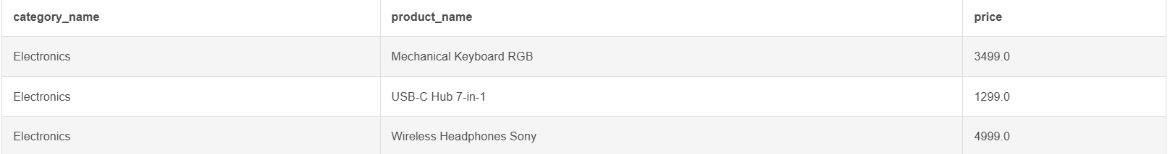

Q8. Three-table join: review, user and product
SELECT u.username, p.product_name, r.rating, r.comment
FROM Review r
JOIN Users u ON r.user_id = u.user_id
JOIN Product p ON r.product_id = p.product_id
ORDER BY r.rating DESC;
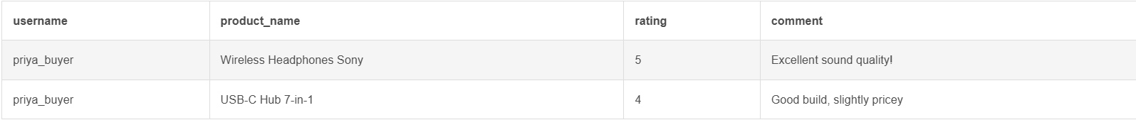

Q9. Cart entries with user and product details
SELECT u.username, p.product_name, c.quantity, c.added_at
FROM Cart c
JOIN Users u ON c.user_id = u.user_id
JOIN Product p ON c.product_id = p.product_id
ORDER BY c.added_at;

Q10. Orders with return status
SELECT o.order_id, o.order_status, rr.status AS return_status
FROM Orders o
LEFT JOIN Return_Request rr ON o.order_id = rr.order_id
ORDER BY o.order_id;

5.3 Aggregate Functions, GROUP BY and HAVING
Q.No | Function Used | SQL Statement | Output / Evidence
Q11 | Product price statistics | SELECT COUNT(*) AS total_products,  MIN(price) AS lowest_price,  MAX(price) AS highest_price,  ROUND(AVG(price), 2) AS average_price  FROM Product; | For the three supplied products: count 3, lowest 1299.00, highest 4999.00, average 3265.67.
Q12 | Products by seller | SELECT seller_id, COUNT(*) AS products_listed,  ROUND(AVG(price), 2) AS average_price  FROM Product  GROUP BY seller_id; | The supplied product rows all use seller_id 1; parent Seller row is absent.
Q13 | Categories with more than one product | SELECT c.category_name, COUNT(p.product_id) AS product_count  FROM Category c  LEFT JOIN Product p ON c.category_id = p.category_id  GROUP BY c.category_id, c.category_name  HAVING COUNT(p.product_id) > 1; | Requires Category rows.
Q14 | Review average by product | SELECT p.product_name, COUNT(r.review_id) AS review_count,  ROUND(AVG(r.rating), 2) AS average_rating  FROM Product p  LEFT JOIN Review r ON p.product_id = r.product_id  GROUP BY p.product_id, p.product_name  ORDER BY average_rating DESC; | Can be evaluated for the supplied two reviewed products and one unreviewed product.

Q11. Product price statistics
SELECT COUNT(*) AS total_products,
MIN(price) AS lowest_price,
MAX(price) AS highest_price,
ROUND(AVG(price), 2) AS average_price
FROM Product;

Q12. Products by seller
SELECT seller_id, COUNT(*) AS products_listed,
ROUND(AVG(price), 2) AS average_price
FROM Product
GROUP BY seller_id;

Q13. Categories with more than one product
SELECT c.category_name, COUNT(p.product_id) AS product_count
FROM Category c
LEFT JOIN Product p ON c.category_id = p.category_id
GROUP BY c.category_id, c.category_name
HAVING COUNT(p.product_id) > 1;

Q14. Review average by product
SELECT p.product_name, COUNT(r.review_id) AS review_count,
ROUND(AVG(r.rating), 2) AS average_rating
FROM Product p
LEFT JOIN Review r ON p.product_id = r.product_id
GROUP BY p.product_id, p.product_name
ORDER BY average_rating DESC;
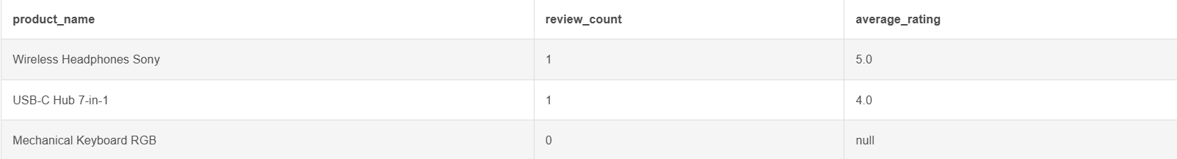

5.4 Nested and Correlated Subqueries
Q.No | Type | SQL Statement | Output / Evidence
Q15 | Nested: products above average price | SELECT product_id, product_name, price  FROM Product  WHERE price > (SELECT AVG(price) FROM Product)  ORDER BY price DESC; | With supplied product prices, Wireless Headphones Sony and Mechanical Keyboard RGB are above the average.
Q16 | Correlated: most expensive product per seller | SELECT p.seller_id, p.product_name, p.price  FROM Product p  WHERE p.price = (  SELECT MAX(p2.price)  FROM Product p2  WHERE p2.seller_id = p.seller_id  ); | Uses product rows; seller parent details are not required for this query.
Q17 | Nested: users who wrote a five-star review | SELECT user_id, username  FROM Users  WHERE user_id IN (  SELECT user_id FROM Review WHERE rating = 5  ); | With supplied rows, the qualifying username is priya_buyer.

Q15. Nested: products above average price
SELECT product_id, product_name, price
FROM Product
WHERE price > (SELECT AVG(price) FROM Product)
ORDER BY price DESC;
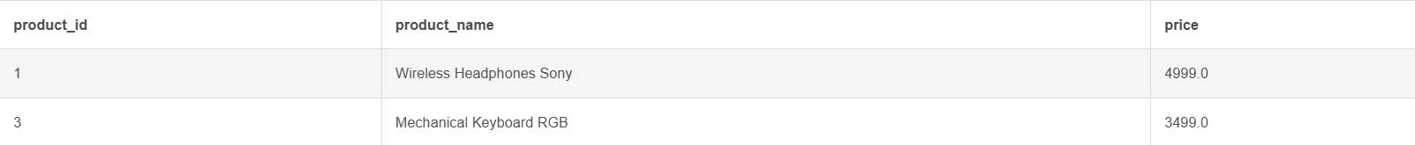

Q16. Correlated: most expensive product per seller
SELECT p.seller_id, p.product_name, p.price
FROM Product p
WHERE p.price = (
SELECT MAX(p2.price)
FROM Product p2
WHERE p2.seller_id = p.seller_id
);

Q17. Nested: users who wrote a five-star review
SELECT user_id, username
FROM Users
WHERE user_id IN (
SELECT user_id FROM Review WHERE rating = 5
);

5.5 Views and Relational Set Operations
Q.No | View / Set Operation | SQL Statement | Output / Evidence
Q18 | Simple product view | CREATE VIEW v_available_products AS  SELECT product_id, seller_id, product_name, price, discount_pct, stock  FROM Product  WHERE stock > 0; | Simple single-table view; update capability depends on DBMS rules.
Q19 | Aggregate review view | CREATE VIEW v_product_review_summary AS  SELECT p.product_id, p.product_name,  COUNT(r.review_id) AS review_count,  ROUND(AVG(r.rating), 2) AS average_rating  FROM Product p  LEFT JOIN Review r ON p.product_id = r.product_id  GROUP BY p.product_id, p.product_name; | Join/aggregate view intended for reporting and normally read-only.
Q20 | UNION: users who are buyers or admins | SELECT user_id FROM Users WHERE user_role = 'Buyer'  UNION  SELECT user_id FROM Users WHERE user_role = 'Admin'; | With supplied rows, user_id 2 and 3 are returned.
Q21 | INTERSECT: users who wrote reviews and are buyers | SELECT user_id FROM Users WHERE user_role = 'Buyer'  INTERSECT  SELECT user_id FROM Review; | With supplied rows and MySQL versions supporting INTERSECT, user_id 2 is returned.
Q22 | EXCEPT: users with no reviews | SELECT user_id FROM Users  EXCEPT  SELECT user_id FROM Review; | With supplied rows, user_id 1 and 3 are returned; use an anti-join if EXCEPT is unavailable.
Q23 | Anti-join equivalent for EXCEPT | SELECT u.user_id, u.username  FROM Users u  LEFT JOIN Review r ON r.user_id = u.user_id  WHERE r.user_id IS NULL; | Portable MySQL alternative; with supplied rows, ravi_shop and admin_user are returned.

Q18. Simple product view
CREATE VIEW v_available_products AS
SELECT product_id, seller_id, product_name, price, discount_pct, stock
FROM Product
WHERE stock > 0;


Q19. Aggregate review view
CREATE VIEW v_product_review_summary AS
SELECT p.product_id, p.product_name,
COUNT(r.review_id) AS review_count,
ROUND(AVG(r.rating), 2) AS average_rating
FROM Product p
LEFT JOIN Review r ON p.product_id = r.product_id
GROUP BY p.product_id, p.product_name;

Q20. UNION: users who are buyers or admins
SELECT user_id FROM Users WHERE user_role = 'Buyer'
UNION
SELECT user_id FROM Users WHERE user_role = 'Admin';
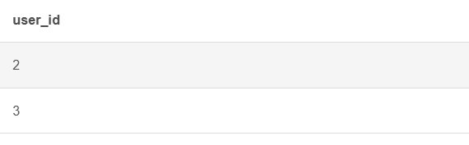

Q21. INTERSECT: users who wrote reviews and are buyers
SELECT user_id FROM Users WHERE user_role = 'Buyer'
INTERSECT
SELECT user_id FROM Review;
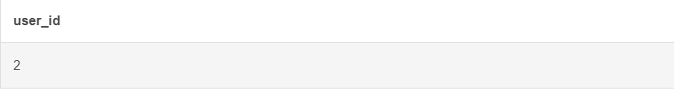

Q22. EXCEPT: users with no reviews
SELECT user_id FROM Users
EXCEPT
SELECT user_id FROM Review;
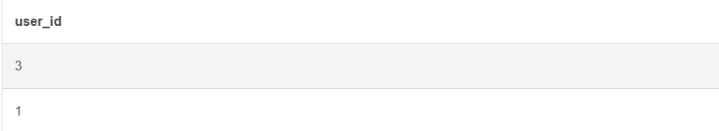

Q23. Anti-join equivalent for EXCEPT
SELECT u.user_id, u.username
FROM Users u
LEFT JOIN Review r ON r.user_id = u.user_id
WHERE r.user_id IS NULL;
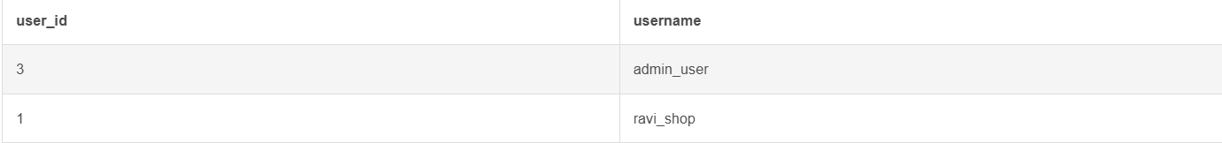

5.6 DCL and TCL Operations
Q.No | Command | Purpose | SQL Statement | Output / Evidence
Q24 | GRANT | Give a reporting user read-only access | GRANT SELECT ON online_shopping_system.*  TO 'shop_reporter'@'localhost'; | The user account must exist or be created by an authorized administrator.
Q25 | REVOKE | Remove write permission if previously granted | REVOKE INSERT, UPDATE, DELETE  ON online_shopping_system.*  FROM 'shop_reporter'@'localhost'; | Requires an existing account and administrator privileges.
Q26 | COMMIT | Commit a cart update | START TRANSACTION;  UPDATE Cart SET quantity = quantity + 1  WHERE user_id = 2 AND product_id = 1;  COMMIT; | No Cart row is supplied, so no execution result is available.
Q27 | SAVEPOINT and ROLLBACK | Undo a later update while retaining an earlier update | START TRANSACTION;  UPDATE Product SET stock = stock - 1 WHERE product_id = 1;  SAVEPOINT after_stock_update;  UPDATE Product SET discount_pct = 20 WHERE product_id = 1;  ROLLBACK TO SAVEPOINT after_stock_update;  COMMIT; | Demonstration only; execute against a controlled test copy.
Q28 | Full rollback | Cancel a transaction | START TRANSACTION;  UPDATE Orders SET order_status = 'Shipped'  WHERE order_id = 1;  ROLLBACK; | No Orders row is supplied.

Q24. GRANT
GRANT SELECT ON online_shopping_system.*
TO 'shop_reporter'@'localhost';

Q25. REVOKE
REVOKE INSERT, UPDATE, DELETE
ON online_shopping_system.*
FROM 'shop_reporter'@'localhost';

Q26. COMMIT
START TRANSACTION;
UPDATE Cart SET quantity = quantity + 1
WHERE user_id = 2 AND product_id = 1;
COMMIT;

Q27. SAVEPOINT and ROLLBACK
START TRANSACTION;
UPDATE Product SET stock = stock - 1 WHERE product_id = 1;
SAVEPOINT after_stock_update;
UPDATE Product SET discount_pct = 20 WHERE product_id = 1;
ROLLBACK TO SAVEPOINT after_stock_update;
COMMIT;

Q28. Full rollback
START TRANSACTION;
UPDATE Orders SET order_status = 'Shipped'
WHERE order_id = 1;
ROLLBACK;

CHAPTER 6: MODULES AND FUNCTIONALITIES
S.No | Module Name | Functionality | Tables Involved
1 | User and Role Management | Stores usernames, emails, password hashes, roles and account timestamps. | Users
2 | Seller Management | Associates a seller profile with a user, records shop and GST identity, and provides a base for seller metrics. | Users, Seller
3 | Product and Category Management | Stores product listings, prices, discounts, stock and category associations. | Category, Product, Seller
4 | Shopping Cart Management | Stores products selected by users, quantities and timestamps while preventing duplicate user-product rows. | Users, Product, Cart
5 | Order Management | Stores order ownership, dates, status and estimated delivery. The source mentions order items conceptually but does not supply an Order_Item table. | Users, Orders, Order_Item conceptually
6 | Reviews and Ratings | Allows users to review products, applies a rating range and prevents duplicate reviews for one user-product pair. | Users, Product, Review
7 | Returns Management | Stores a return request for an order, its reason, state and refund amount. | Orders, Users, Return_Request

User and Role Management: Stores usernames, emails, password hashes, roles and account timestamps.
Seller Management: Associates a seller profile with a user, records shop and GST identity, and provides a base for seller metrics.
Product and Category Management: Stores product listings, prices, discounts, stock and category associations.
Shopping Cart Management: Stores products selected by users, quantities and timestamps while preventing duplicate user-product rows.
Order Management: Stores order ownership, dates, status and estimated delivery. The source mentions order items conceptually but does not supply an Order_Item table.
Reviews and Ratings: Allows users to review products, applies a rating range and prevents duplicate reviews for one user-product pair.
Returns Management: Stores a return request for an order, its reason, state and refund amount.

CHAPTER 7: RESULTS – SAMPLE OUTPUTS AND SCREENSHOTS

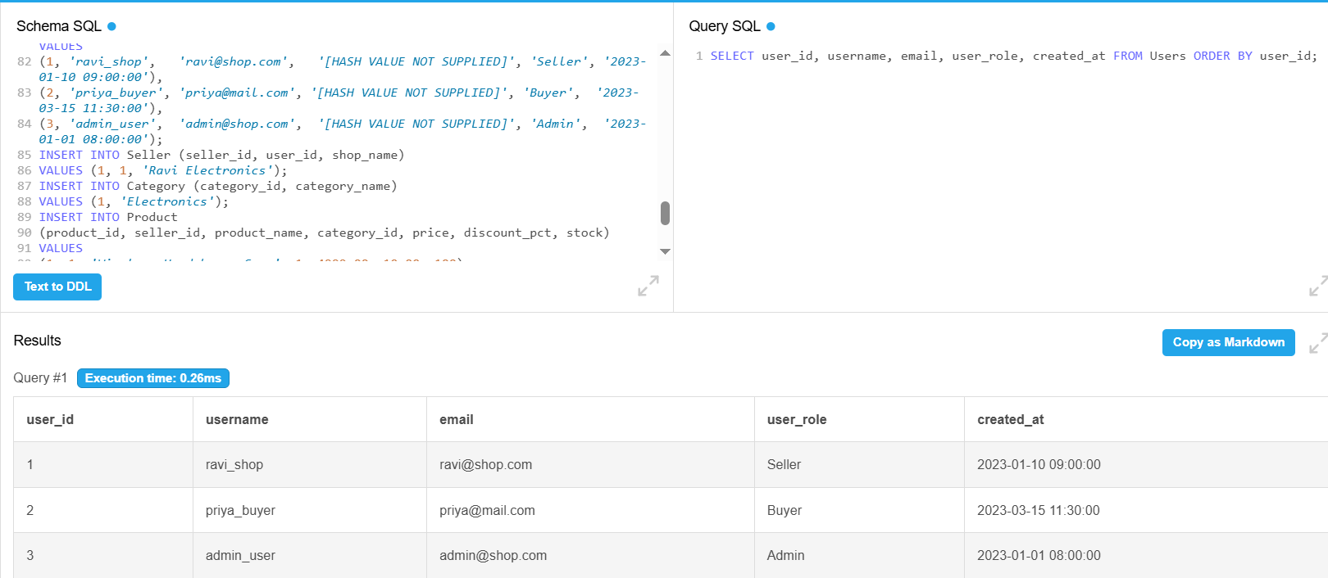
Fig. 7.1: User Retrieval Output

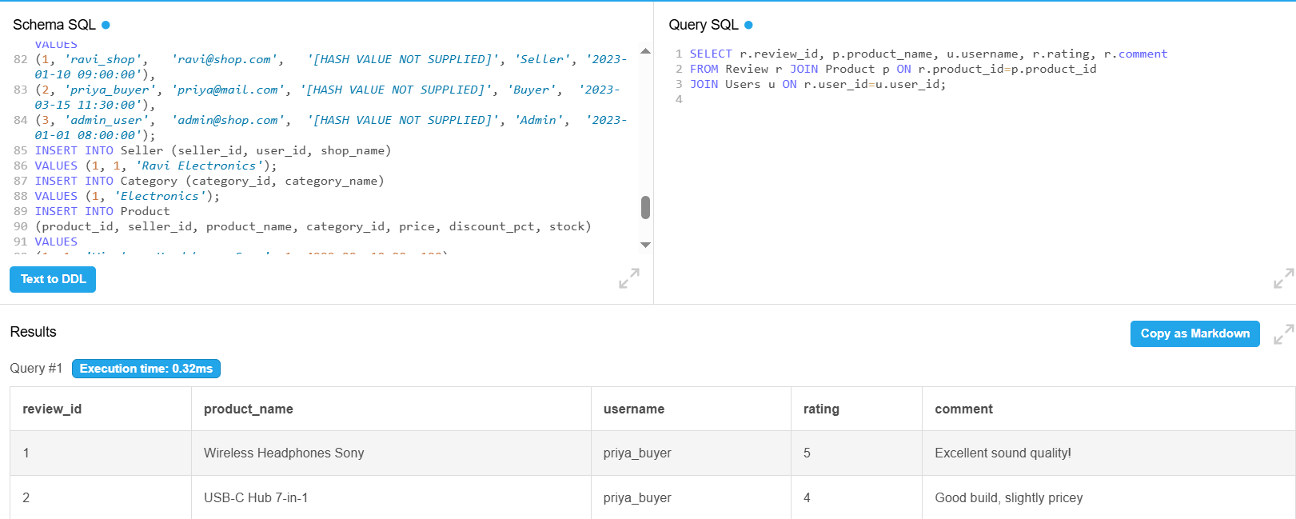 Fig. 7.2: Product Review Output
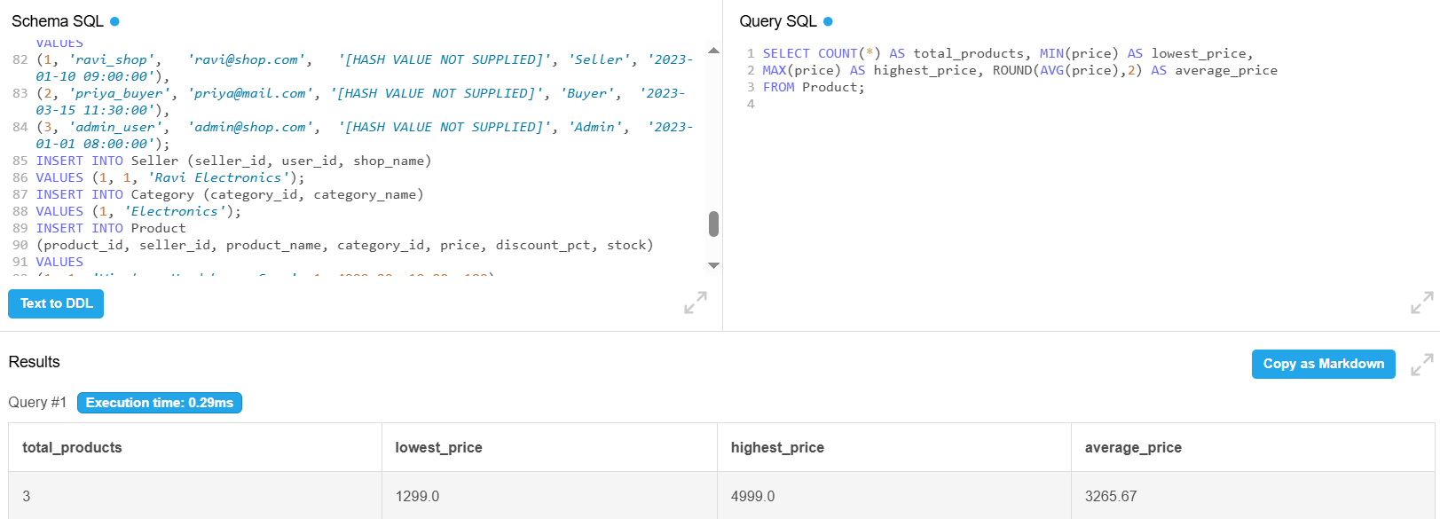
Fig. 7.3: Product Aggregate Output

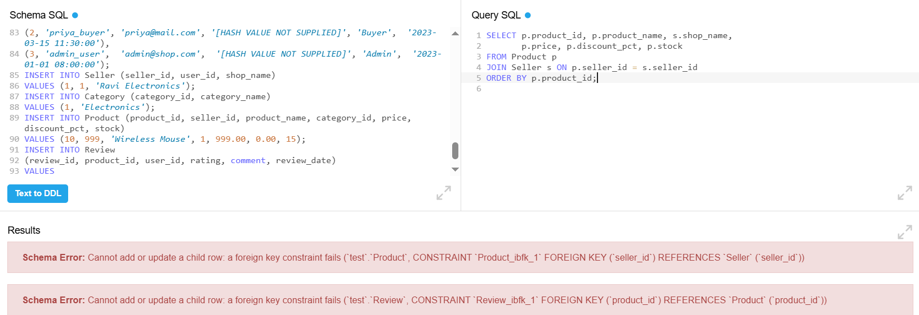 Fig. 7.4: Constraint Validation Output

CHAPTER 8: TESTING AND DATA VALIDATION

TC No. | Test Case Description | Input / Action | Expected Result | Actual Result | Status
TC-01 | Primary key uniqueness | Insert a duplicate Users.user_id | Duplicate key error | Not executed in source | Pending evidence
TC-02 | Unique username | Insert another user with username ravi_shop | UNIQUE violation | Not executed in source | Pending evidence
TC-03 | Unique email | Insert another user with email ravi@shop.com | UNIQUE violation | Not executed in source | Pending evidence
TC-04 | Product price check | Insert Product with price = -1 | CHECK violation | Not executed in source | Pending evidence
TC-05 | Cart quantity check | Insert Cart with quantity = 0 | CHECK violation | Not executed in source | Pending evidence
TC-06 | Review rating check | Insert Review with rating = 6 | CHECK violation | Not executed in source | Pending evidence
TC-07 | Product foreign key | Use a seller_id absent from Seller | FOREIGN KEY violation | Not executed in source | Pending evidence
TC-08 | Cart composite unique | Repeat same user_id and product_id | Duplicate key error | Not executed in source | Pending evidence
TC-09 | Review composite unique | Repeat same product_id and user_id | Duplicate key error | Not executed in source | Pending evidence
TC-10 | Return one-to-one | Repeat an order_id in Return_Request | UNIQUE violation | Not executed in source | Pending evidence
TC-11 | Default values | Omit user_role, stock or status | Defined DEFAULT is applied | Not executed in source | Pending evidence
TC-12 | Query correctness | Execute Q11 product statistics | 3 products; 1299.00; 4999.00; 3265.67 | Calculated from supplied rows | Pending execution screenshot

CHAPTER 9: GITHUB REPOSITORY AND TEAM CONTRIBUTION

9.1 Repository Details
GitHub Repository Link: https://github.com/sahithichinta45-dotcom/ONLINE-SHOPPING-SYSTEM

9.2 Team Responsibilities and Contribution
S.No | Student Name | Roll Number | Role / Responsibility | Contribution status
1 | CHINTA SAHITHI | 25B11AI210 | ONLINE SHOPPING SYSTEM DATABASE DESIGN & DDL SCRIPTING | COMPLETED  (100%)
2 | GOLLAVILLI RESHMA APARNA | 25B11AI352 | DML DATA POPULATION & ENTITY RECORD MANAGEMENT | COMPLETED  (100%)
3 | NARLA BALA CHANDRA VEERA MANIKANTA ESWAR | 25B11AI827 | SQL QUERIES,JOINS & SUBQUERIES | COMPLETED  (100%)
4 | ELLIPE SUSHANTH ABHINAY DAS | 25B11AI297 | VIEWS,AGGREGATIONS,TESTING & QUERY ANALYSIS | COMPLETED  (100%)

CHAPTER 10: CONCLUSION AND FUTURE ENHANCEMENTS

10.1 Conclusion
The Online Shopping System design models eight primary entities: Users, Seller, Category, Product, Cart, Orders, Review and Return_Request. The supplied DDL applies primary keys, foreign keys, uniqueness rules, mandatory fields, range checks and default values to support consistent data management. The design also explains how multi-valued attributes and many-to-many associations should be decomposed for normalization, and it identifies derived values that should be calculated rather than redundantly stored.
The supplied sample data demonstrates three users, three products and two reviews. The report defines more than fifteen SQL operations across retrieval, joins, aggregation, subqueries, views, set operations, DCL and TCL. Because execution logs and several parent/supporting data sets were not included, the report distinguishes calculated sample outputs from unverified execution evidence. The main deliverable is therefore a complete design-and-implementation documentation baseline that can be finalized after the missing artifacts are added.

10.2 Limitations of the Present Work
- The supplied DDL does not create Address, Order_Item, User_Phone or Product_Images even though the conceptual design refers to them.
- Orders has no executable delivery_address_id column in the supplied DDL, so address-based shipping cannot be implemented by the current script.
- Order line items are not represented by an executable table, so an order-to-product many-to-many relationship and historical unit prices cannot be stored completely.
- The source includes password_hash as a column but does not document authentication, hashing policy or credential management.
- No payment table or payment transaction flow is included.
- No SQL query execution screenshots, DCL/TCL output, repository link, team roster or review progress records were supplied.
- Seller rating, total_sales, final_price, cart_total and total_amount are described as derived but are not implemented as generated columns or views in the supplied DDL.

10.3 Future Enhancements
- Create User_Phone and Product_Images tables to implement the identified multi-valued attributes.
- Create Address and Order_Item tables, then add the corresponding foreign keys and order-line price history.
- Add payment and shipment modules with status transitions and transaction references.
- Create views or generated expressions for final price, cart total, order total, seller rating and total sales.
- Add stored procedures and triggers for stock updates, order placement, returns and audit history.
- Add indexes on foreign-key and search columns, then measure query plans with a larger data set.
- Implement role-based privileges, secure password handling, backups and recovery procedures.
- Develop a front end only after the database contract and transaction rules are finalized.

REFERENCES
- Abraham Silberschatz, Henry F. Korth and S. Sudarshan, “Database System Concepts”, 8th Edition, McGraw-Hill, ISBN: 978-1260230508.
- Raghurama Krishnan and Johannes Gehrke, “Database Management Systems”, 4th Edition, McGraw-Hill, ISBN: 978-1260091195.
- Ramez Elmasri and Shamkant B. Navathe, “Fundamentals of Database Systems”, 7th Edition, Pearson, ISBN: 978-0137504277.
- MySQL Reference Manual, Oracle Corporation: https://dev.mysql.com/doc/refman/8.0/en/
- Capstone DB All Projects — supplied project reference document.
- DBMS Capstone Final Documentation Template — supplied university template.

APPENDIX A – COMPLETE SQL SCRIPT
CREATE TABLE Users (
user_id INT PRIMARY KEY AUTO_INCREMENT,
username VARCHAR(50) UNIQUE NOT NULL,
email VARCHAR(100) UNIQUE NOT NULL,
password_hash VARCHAR(255) NOT NULL,
user_role VARCHAR(20) DEFAULT "Buyer",
created_at DATETIME DEFAULT CURRENT_TIMESTAMP
);
CREATE TABLE Seller (
seller_id INT PRIMARY KEY AUTO_INCREMENT,
user_id INT UNIQUE NOT NULL,
shop_name VARCHAR(100) UNIQUE NOT NULL,
gst_number VARCHAR(20) UNIQUE,
bank_account VARCHAR(20),
FOREIGN KEY (user_id) REFERENCES Users(user_id)
);
CREATE TABLE Category (
category_id INT PRIMARY KEY AUTO_INCREMENT,
category_name VARCHAR(100) NOT NULL UNIQUE
);
CREATE TABLE Product (
product_id INT PRIMARY KEY AUTO_INCREMENT,
seller_id INT NOT NULL,
product_name VARCHAR(200) NOT NULL,
category_id INT,
price DECIMAL(10,2) NOT NULL CHECK (price >= 0),
discount_pct DECIMAL(5,2) DEFAULT 0,
stock INT DEFAULT 0,
FOREIGN KEY (seller_id) REFERENCES Seller(seller_id),
FOREIGN KEY (category_id) REFERENCES Category(category_id)
);
CREATE TABLE Cart (
cart_id INT PRIMARY KEY AUTO_INCREMENT,
user_id INT NOT NULL,
product_id INT NOT NULL,
quantity INT NOT NULL CHECK (quantity > 0),
added_at DATETIME DEFAULT CURRENT_TIMESTAMP,
UNIQUE (user_id, product_id),
FOREIGN KEY (user_id) REFERENCES Users(user_id),
FOREIGN KEY (product_id) REFERENCES Product(product_id)
);
CREATE TABLE Orders (
order_id INT PRIMARY KEY AUTO_INCREMENT,
user_id INT NOT NULL,
order_date DATETIME DEFAULT CURRENT_TIMESTAMP,
order_status VARCHAR(30) DEFAULT "Placed",
estimated_delivery DATE,
FOREIGN KEY (user_id) REFERENCES Users(user_id)
);
CREATE TABLE Review (
review_id INT PRIMARY KEY AUTO_INCREMENT,
product_id INT NOT NULL,
user_id INT NOT NULL,
rating INT CHECK (rating BETWEEN 1 AND 5),
comment TEXT,
review_date DATE DEFAULT (CURRENT_DATE),
helpful_votes INT DEFAULT 0,
UNIQUE (product_id, user_id),
FOREIGN KEY (product_id) REFERENCES Product(product_id),
FOREIGN KEY (user_id) REFERENCES Users(user_id)
);
CREATE TABLE Return_Request (
return_id INT PRIMARY KEY AUTO_INCREMENT,
order_id INT UNIQUE NOT NULL,
user_id INT NOT NULL,
reason TEXT,
return_date DATE,
status VARCHAR(20) DEFAULT "Requested",
refund_amount DECIMAL(10,2),
FOREIGN KEY (order_id) REFERENCES Orders(order_id),
FOREIGN KEY (user_id) REFERENCES Users(user_id)
);

